Swimming kids are smarter

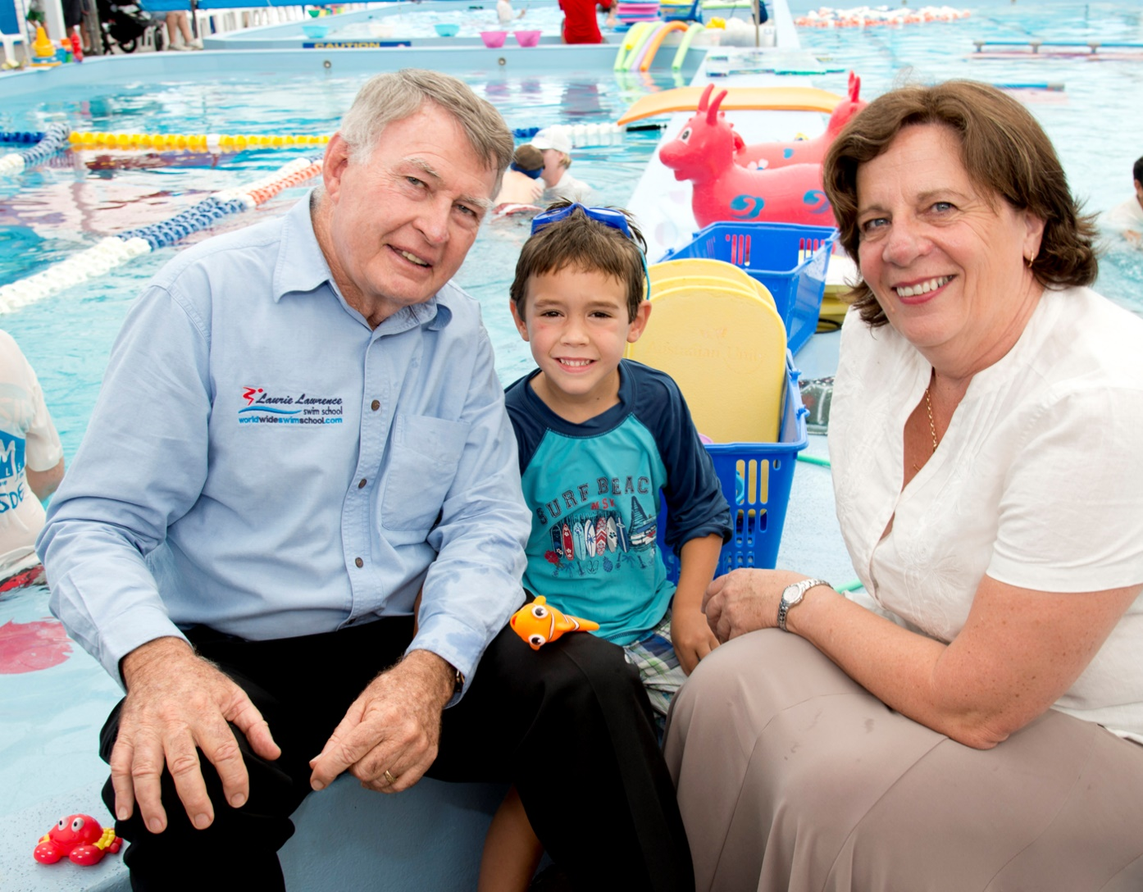Swim coach Laurie Lawrence and Professor Robyn Jorgensen with swim school student Billy Green.

Children who learn how to swim at a young age are reaching many developmental milestones earlier than the norm.

Researchers from the [Griffith Institute for Educational Research](http://www.griffith.edu.au/education/griffith-institute-educational-research) surveyed parents of 7000 under-fives from Australia, New Zealand and the US over three years.

A further 180 children aged 3, 4 and 5 years have been involved in intensive testing, making it the world’s most comprehensive [study](http://www.youtube.com/watch?v=fmh1sOTo4Iw&list=PL06BB77D61F4886F8&index=2&feature=plcp) into early-years swimming.

Lead researcher [Professor Robyn Jorgensen](http://www.griffith.edu.au/education/school-education-professional-studies/staff/academic-staff/robyn-jorgensen) says the [study](http://www.griffith.edu.au/__data/assets/pdf_file/0019/470251/early-year-swim-interim-report-2012.pdf)shows young children who participate in early-years swimming achieve a wide range of skills earlier than the normal population.

“Many of these skills are those that help young children into the transition into formal learning contexts such as pre-school or school.

“The research also found significant differences between the swimming cohort and non-swimmers regardless of socio-economic background.

“While the two higher socio-economic groups performed better than the lower two in testing, the four SES groups all performed better than the normal population.

The researchers also found there were no gender differences between the research cohort and the normal population.

As well as achieving physical milestones faster, children also scored significantly better in visual-motor skills such as cutting paper, coloring in and drawing lines and shapes, and many mathematically-related tasks. Their oral expression was also better as well as in the general areas of literacy and numeracy.

“Many of these skills are highly valuable in other learning environments and will be of considerable benefit for young children as they transition into pre-schools and school.”

The study is a joint project between Griffith University, Kids Alive Swim Program and Swim Australia.

MEDIA: Deborah Marshall 0408 727 734

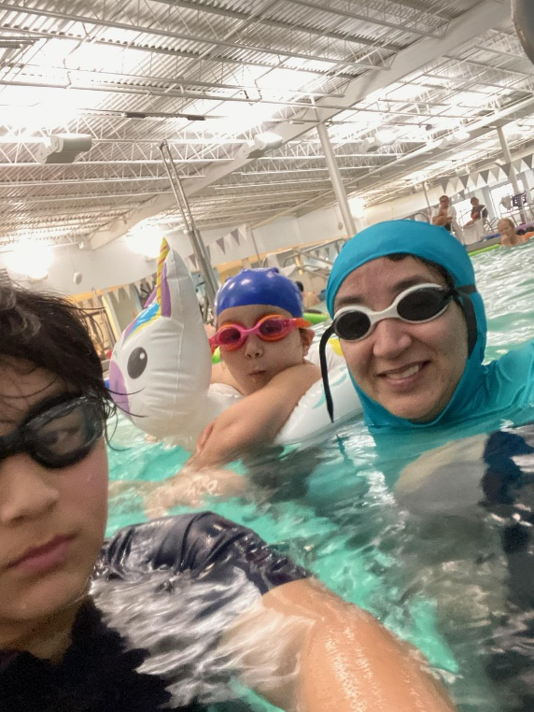

.

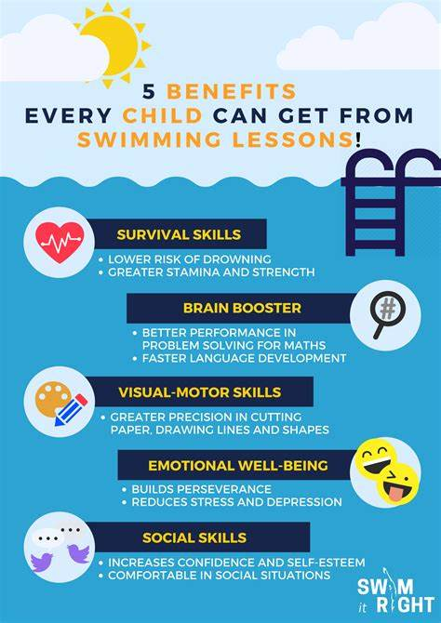

**1. Like Classroom, Like Swimming Pool**

One reason swimmers get a head start in their development is because of the similarities between what is taught in a classroom and what is learned in the pool!

Children are exposed to numbers at an early stage when they take swimming lessons. This is because coaches are constantly using numbers in their conversations with their students.

For example, coaches will usually count “1-2-3 GO” at the start of an activity. Kids will also have to count the number of seconds they must hold their breath underwater or when doing an activity.

Starting swimming lessons at a young age also exposes children to language frequently. They often have to follow instructions given by the coaches, like teachers in classrooms.

Children can also voice out when they are unsure about anything during the swimming lesson. This builds on their oral expression at an early stage. 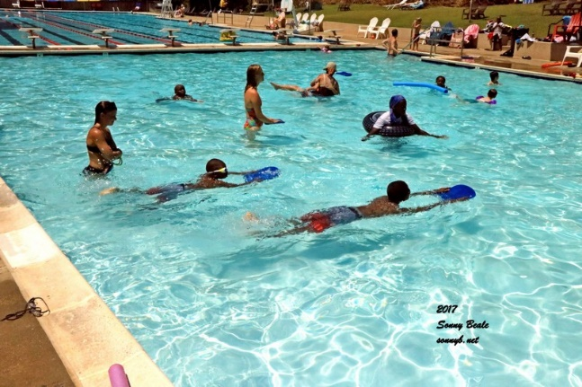

Furthermore, swimming helps to hone our motor skills! Our coordination improves overtime as we exercise the muscles in our body. These drills include flat palms for freestyle or pointing our toes for flutter kick.

Young swimmers fare better in visual-motor skills like cutting paper, drawing lines and shapes and coloring in. These skills are highly valuable, as they are beneficial in getting children ready for school.

**2. Memory Booster**

Besides the classroom like experience we have in the pool, another reason swimming makes us smarter is its effect of improving our memory.

A part of our brain consists of the hippocampus, which is a fundamental component of our brain’s learning and memory systems. Aerobic exercises, like swimming, are found to have a significant impact on the growth of the hippocampus.

By swimming regularly, the hippocampus will increase, allowing more oxygen to flow into our brain. This will in turn help to boost our memory capacity!

A strong memory is a definite key to retaining content-heavy information, which is necessary at school and work.

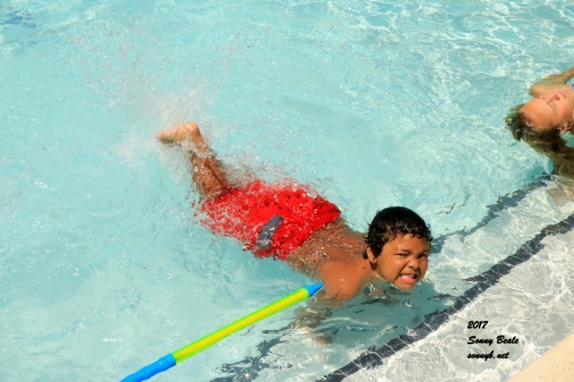**3. Focus, Focus and More Focus**

Another great benefit swimming has in the brain department is to help sharpen our focus and concentration, ensuring we do not stray away from our tasks.

Swimming can increase the attention span of children. Swimmers are more likely to dismiss the distractions around them and focus better in their work.

Having the perseverance to complete laps instead of stopping halfway, and focusing on executing each stroke correctly helps sharpen our attention and focus greatly.

So, what are you waiting for?

It’s time to head down to the pool with your kids, and get those brain juices flowing!